For placing in degraded mode
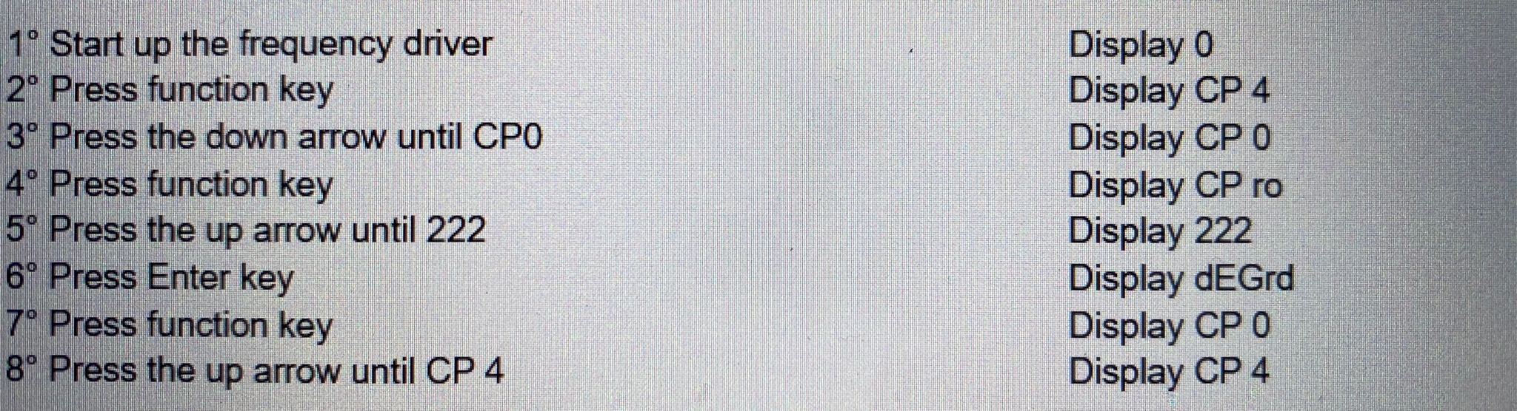

For returning to normal mode
