Vicario 1989 – AUTEC Load Cell Calibration Troubleshooting
Service case summary • AN1 “Too close to DTA” during two-point load calibration
RESOLUTION: The replacement CELMI load pin was producing the correct magnitude of signal, but its AN1 signal polarity was reversed at the AUTEC input. Swapping only the two signal conductors corrected the polarity; DTB was then accepted and calibration completed.

1. Reported problem
After replacement of the crane load pin, the AUTEC AIRRIAMIA load display could save the unloaded calibration point (DTA = 0), but with a known 4,000 lb test load suspended the receiver immediately displayed “Too close to DTA” when Set DTB was selected. The error appeared before the 4,000 lb value could be entered.
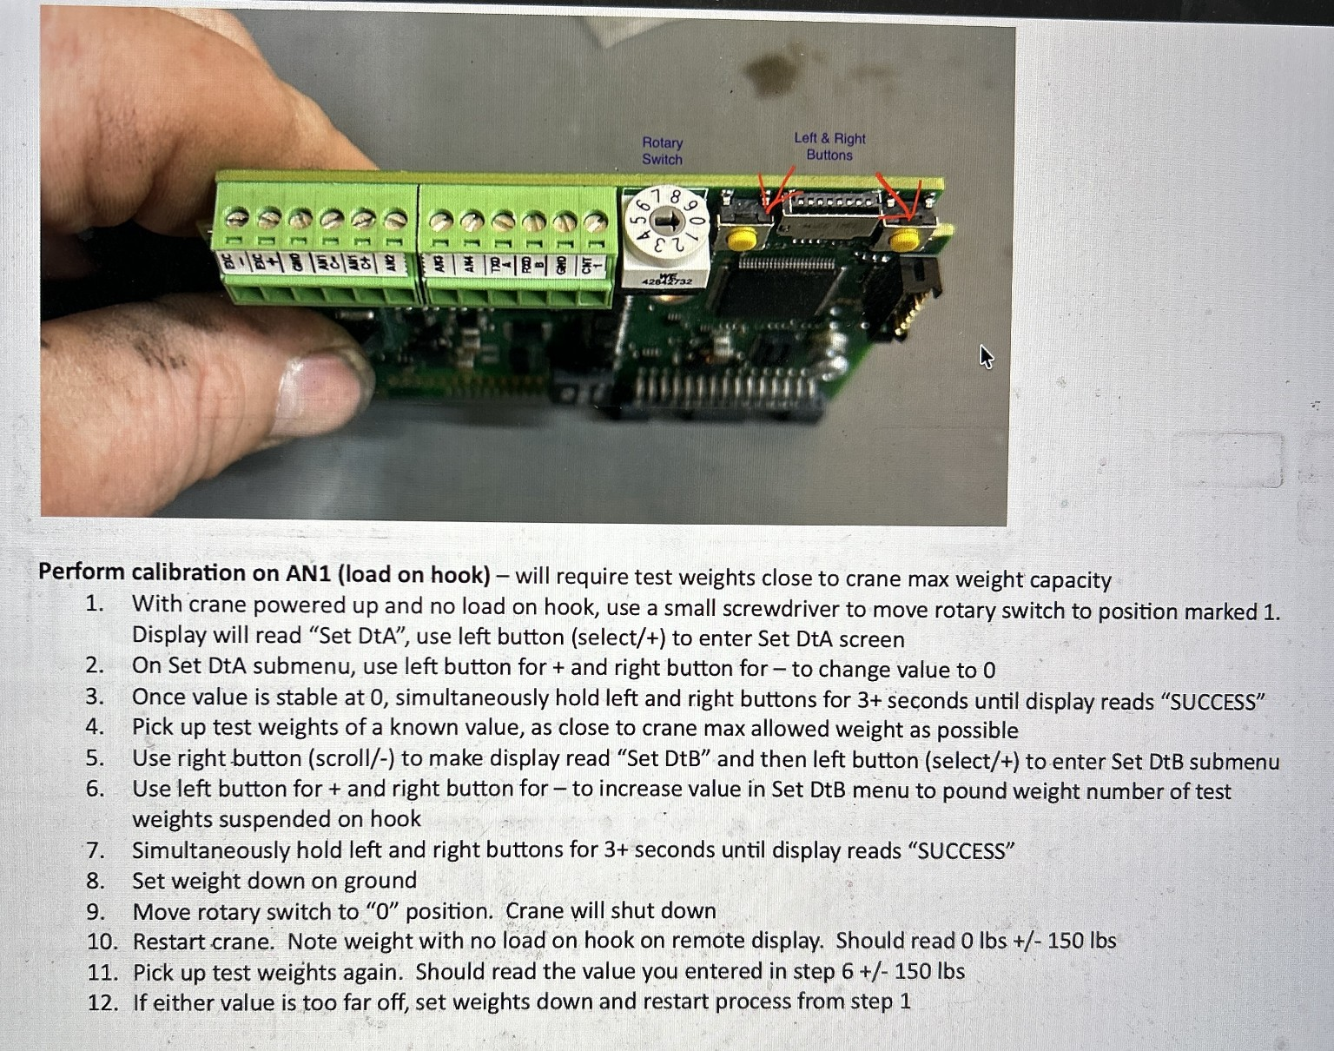
Figure 1 – Field calibration instruction sheet used for the DTA/DTB procedure.

2. Equipment and configuration checked
Item | Observed / verified
Crane | Vicario 1989; maximum hook capacity 4,400 lb
Test weight | Known 4,000 lb suspended load (~91% of maximum hook capacity)
Receiver input | AUTEC AIRRIAMIA multi-input card, AN1 load-cell input
Replacement load pin | CELMI PRC180214, four active conductors plus NC
Meter | Fluke 179; DC mV used for bridge signal measurements
AN1 gain | S4-1 ON, S4-2 ON, S4-3 OFF = 800× load-cell gain (maximum listed gain)
Offset | S4-4 ON = 0 V offset; MENU OFS adjustments are not active in this setting
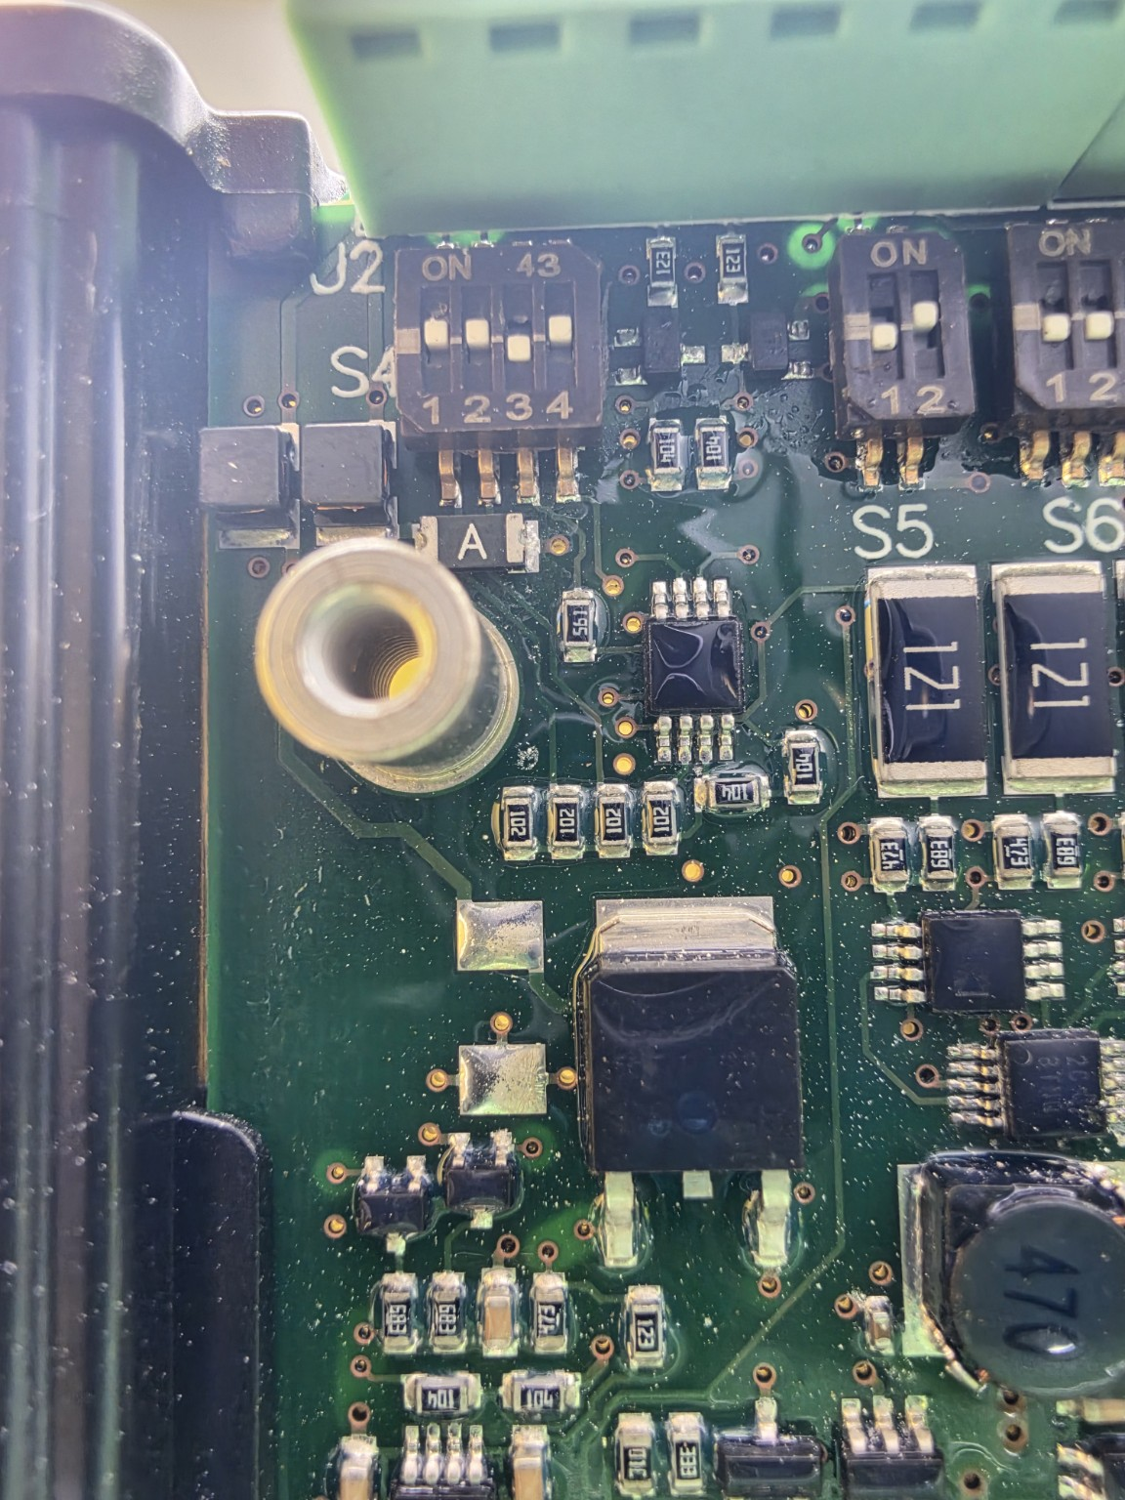
Figure 2 – S4 close-up. “ON” is toward the top; switches 1 and 2 are ON, 3 is OFF, and 4 is ON.

3. Electrical troubleshooting
The bridge and receiver were checked before changing calibration parameters. These measurements showed that the new load pin was electrically active and that the receiver was supplying excitation.
Check | Measured value | Interpretation
Excitation, EXC− to EXC+ | 10.44 VDC | Receiver excitation present
Bridge resistance, Black ↔ Blue | 353 Ω | Nominal ~350 Ω bridge pair
Bridge resistance, Red ↔ White | 353 Ω | Nominal ~350 Ω bridge pair
AN1 signal, unloaded | about −0.2 mV before correction | Near-zero bridge output
AN1 signal, 4,000 lb | about −6.2 mV before correction | Strong signal change, but negative polarity
Signal span | about 6.0 mV | DTA and loaded points were physically well separated at the cell
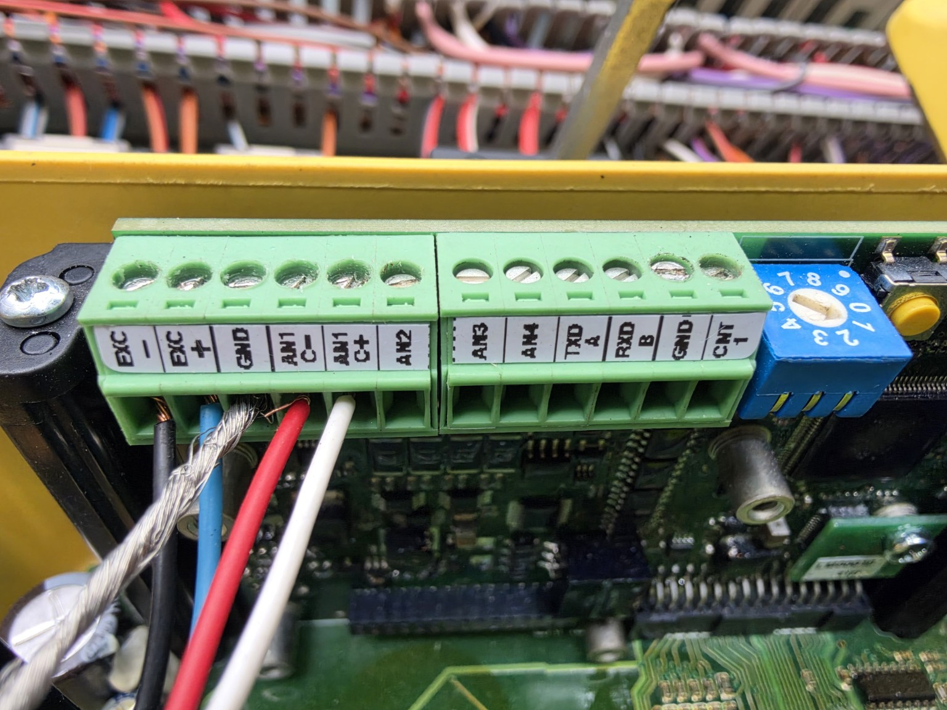
Figure 3 – AUTEC terminal strip. AN1 uses the dedicated C− and C+ differential signal terminals; GND is not the load-cell signal return.
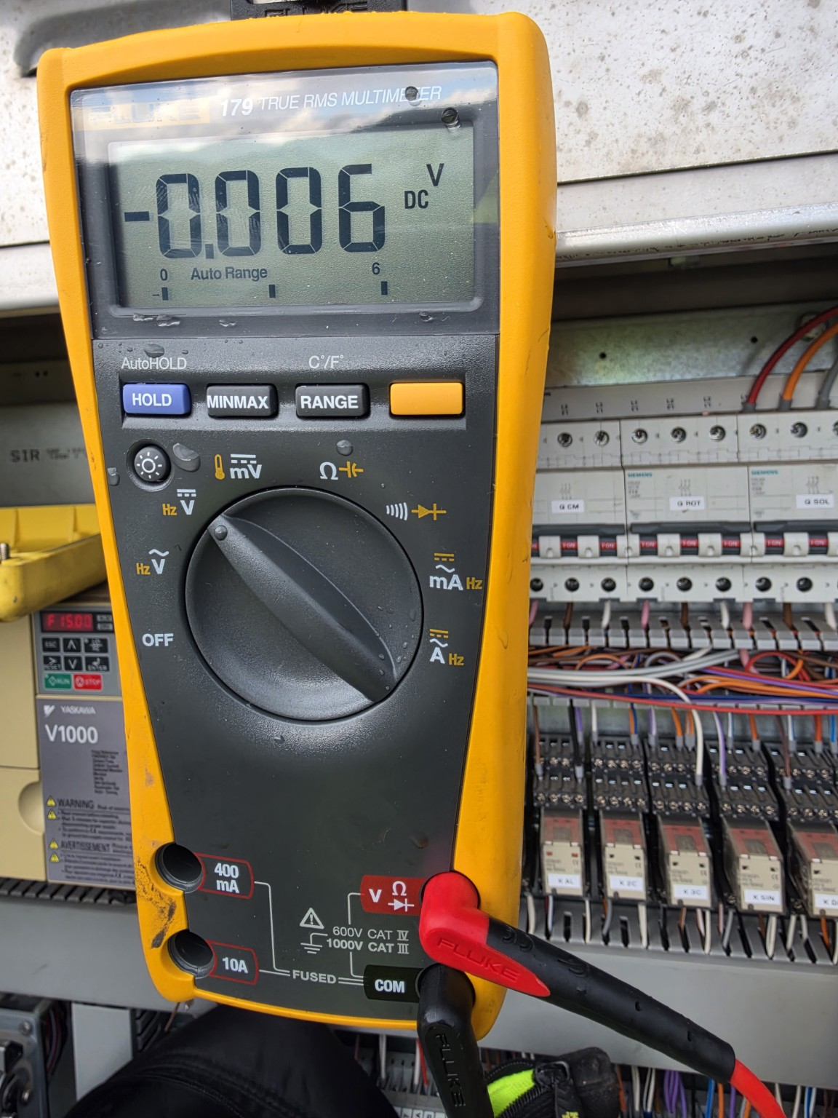
Figure 4 – Fluke 179 used to measure the low-level load-cell signal in DC millivolts.

4. Key diagnostic finding: signal polarity
With the meter red probe on AN1 C+ and black probe on AN1 C−, the original connection produced approximately −0.2 mV unloaded and −6.2 mV at 4,000 lb. Therefore the magnitude increased normally with load, but C+ became more negative than C−. This pointed to reversed signal polarity rather than a failed bridge or insufficient excitation.
Important: The AUTEC manual defines AN1 C− as the negative load-cell/input signal and AN1 C+ as the positive signal. The manual does not define the internal numerical threshold behind the “Too close to DTA” message, so the exact firmware logic was not established. The polarity correction was confirmed by measurement and by the successful DTB calibration afterward.

5. Corrective action
With the receiver powered down, only the two load-cell signal conductors were interchanged. The excitation conductors and DIP-switch configuration were left unchanged.
Function | Before troubleshooting | Corrected connection
EXC− | Black | Black – unchanged
EXC+ | Blue | Blue – unchanged
AN1 C− | Red | White
AN1 C+ | White | Red
After the swap, the measured signal polarity reversed as expected: approximately +0.2 mV unloaded and +6.2 mV with the 4,000 lb load. This verified the wiring change electrically before calibration was repeated.

6. Calibration procedure after correction
- Set the 4,000 lb test load down and leave the hook unloaded.
- Place the AUTEC rotary selector at position 1 (MENU AN1).
- Select Set DtA, enter 0 lb, then hold both buttons for more than 3 seconds until SUCCESS.
- Lift the known 4,000 lb test load completely clear and allow it to stabilize.
- Scroll to Set DtB and select it. After the polarity correction, the receiver allowed entry instead of reporting “Too close to DTA.”
- Enter 4000 and save by holding both buttons for more than 3 seconds until SUCCESS.
- Set the load down, return the rotary selector to position 0, restart the crane, and verify the indication at zero load and again with the known test load.

7. Root cause and service takeaway
Root cause: the replacement load pin’s two signal conductors were landed with opposite polarity relative to the AUTEC AN1 C+/C− input. The bridge itself was healthy, excitation was present, and the load produced roughly a 6 mV signal span. Once the signal pair was reversed, the receiver accepted the loaded DTB point and the calibration worked.
SERVICE TIP: If DTA saves normally but DTB immediately reports “Too close to DTA,” measure the differential AN1 signal at empty hook and at a known load before changing gain or offset settings. Confirm both adequate signal span and correct polarity. Do not assume wire colors alone establish signal +/− on a replacement load pin.

8. Safety and reference notes
This circuit is part of a crane load-indication/overload system. Follow the machine manufacturer’s service procedures and applicable qualified-person requirements. AUTEC instructs technicians not to connect or disconnect cables while the receiver is powered. S8 is not to be modified from the machine technical data. Do not bypass or defeat the load-limiting system during troubleshooting.

